A Novel Deep Learning Approach To Predicting Wildfire Propagation With Transformers
Arthur Qin
Palos Verdes Peninsula High School
2023-2024
Science Research

Abstract
Climate change is the root cause of increasingly frequent and severe wildfires. Predicting wildfire spreading behavior in advance is imperative for wildfire containment and management. However, it is also an extremely challenging task. While different artificial intelligence-based methods have been devised in existing literature, an accurate long-term solution does not yet exist. Thus, this project proposes that transformers, a type of neural architecture thrust into the limelight after the recent success of Large Language Models such as ChatGPT, are better suited for tackling the problem of predicting the spread of wildfires and will achieve better accuracy than existing models reliant on traditional model architectures.
The materials required for the experimental procedures include the open-sourced Next Day Wildfire Spread Dataset and a robust cloud-computing pipeline to optimize the different model parameters for maximum efficiency. For baseline comparison, a Convolutional Autoencoder Machine Learning model will be developed and trained. A new model based on SegFormer, an open-source transformer built by NVIDIA, will be developed and compared to the baseline model.
Comparison of the two models shows significant improvement in Mean Intersection over Union (Mean IoU) score achieved by the transformer model compared to the best performing Autoencoder model. In both training and validation, the SegFormer model exhibits both more consistent and accurate results, with a final evaluation Mean IoU of ≈0.60 compared to ≈0.50 after 100 epochs of training.
These results support the conclusion that transformers are the path forward for AI-based predictions of wildfire propagation. Further research should explore the optimization of transformer architectures and hyperparameters to achieve even better accuracy. There also exists opportunities for real-time prediction capability research.
Introduction
Climate change is often described as the greatest problem of our generation, and is the root cause of increasingly frequent natural disasters and crises. Among those are wildfires, which have been burning larger and hotter every year (Rothermel). While local and federal governmental organizations have passed numerous stopgap measures in an attempt to alleviate the problem, these measures have failed to adequately contain the spread of fires (Feunekes). Current efforts to protect citizens from wildfires in the US have centered around detection and prevention; in other words, trying to prevent wildfires from starting before they even begin (Haghian). While this approach does have its merits, after a wildfire inevitably starts, the possibility of successful containment starts to decline in real time. Firefighters have no accurate direction in which to focus their efforts, nor an accurate “fire map” to visualize the spread of the fire, which plays a crucial role in fire management and containment (Haghian). However, predicting wildfire spreading behavior in advance is an extremely challenging task due to considerable variability in the environmental, meteorological, topological, and other conditions that drastically influence the way fires spread (Xu). A long-term solution to this problem is especially difficult due to the entropic nature of wildfire behavior, and numerous past attempts at creating such an analytical model have fallen short (Finney).
Traditionally, physics-based analytical models for human use have been developed to predict how a fire will spread(Xu). The most influential work was developed by scientists and researchers at the Northern Forest Fire Laboratory (NFFL) over several decades during the 1960s (Rothermel). It consisted of systematic procedures for estimating fire behavior, including the rate of forward spread, intensity, flame length, and size of fires burning in forests and rangelands. Containing detailed instructions for obtaining fuel and weather data, calculating fire behavior, and interpreting the results for application to actual fire problems, the NFFL model has been extensively used in fire prediction, fire planning, dispatching, prescribing fires, and monitoring management of fires. However, a major limitation of the model is that most of the analytical procedures must be learned and practiced diligently by a human to produce proficiency and useful results (Rothermel). The difficulty in use arises in the estimation of the most appropriate inputs for situations that appear very diverse (Rothermel). Prediction accuracy is dependent upon the skill and knowledge of the user and the degree of uniformity or lack of uniformity of the fuels and environmental conditions.
With the development of computing technologies, computational methods have been used to automate the application of analytical fire models to nonuniform conditions by assuming local uniformity data points (local to segments of the fire perimeter) (Green). The most common approach has been to simulate fire growth as a discrete process of ignitions across a regularly spaced landscape grid (hereafter referred to as cellular models) (Green). In general, cellular models account for the spatial diversity of conditions but have limitations in responding appropriately to temporal changes such as shifting wind speed (Green). This limitation was addressed by the vector or wave approach to fire growth modeling, where the fire front is propagated as a continuously expanding fire polygon at specified timesteps (Green). The expansion of the fire polygon is determined by computing the spread rate and direction from each vertex and multiplying by the duration of the timestep (Green). The most commonly used fire modeling simulation software, FARSITE, was developed using this approach, which incorporates physics-based fire models and mathematical models of predetermined fire growth shape, but may not be applicable to real wildfires (Finney). In addition, FARSITE also suffers from its lack of stability in that altering one input variable can dramatically change its predicted output (Finney).
In recent years, advances in AI and big data analysis allowed for novel data- driven solutions to real-world complex problems. Deep-learning technologies have been applied due to the complex nature of wildfire spreading behavior, as well as the high dimensionality and size of the information involved in its prediction. A Deep Forest Wildfire Auto-Encoder (DFWAE) model was developed in (Zohouri) to learn the essential structure of the forest and the fire from a sequence of images for the duration of a fire. It also incorporated the Long Short Term Memory (LSTM) model in a Deep Forest Wildfire Predictor (DFWP) model to produce an image frame representing a possible future distribution of the fire. However, the models were validated using simulated fire images only. In addition, the models’ purely image-based inputs ignore all physical variables limiting their applicability to real wildfires. Alternatively, FireCast (Radke), a 2-D Convolutional Neural Network (CNN) based model was trained to predict the areas surrounding the current fire perimeter that are expected to burn during the following 24 hours given an initial fire perimeter, location, and atmospheric data as input. The model was trained and tested using historical fire data in the Rocky Mountain region of the United States. Therefore, it is limited to a specific region only. Besides, it does not consider fuel characteristics and landscaping information. In addition, the 2-D CNN models identify spatial patterns of data only without exploiting any temporal dependencies among the sequences of inputs.
More recently, generative AI has gained significant attention due to its impressive ability to create realistic and coherent content (Gozalo-Brizuela). For example, text-based models such as OpenAI's GPT can generate paragraphs of text, while image-based models like DeepArt or DALL-E can generate novel images based on textual descriptions. One of the key techniques used in generative AI is generative modeling. This involves training a model on a large dataset and teaching it to understand the underlying patterns and relationships within the data. Once the model has learned these patterns, it can generate new content that is similar to the training data. The current success of generative AI models suggests that they can handle complex multimodal sequential data effectively.
The current state-of-the-art generative model is the transformer model, which was introduced in 2017 (Vaswani) and has since revolutionized NLP tasks. It uses a novel architecture that relies heavily on self-attention mechanisms, which allows the model to focus on different parts of the input sequence when processing each element. This makes it particularly effective for tasks that require understanding of long-range dependencies and relationships between different parts of the input. Therefore, in this project, we propose to design and train a transformer model for tackling the problem of predicting the spread of wildfires. The prediction accuracy of the trained transformer model will be compared with those of a baseline Autoencoder deep-learning model. The hypothesis is that the transformer model will achieve a more reliable and accurate prediction during the evaluation.

Method
Materials
The materials required for the experimental procedures include the Next Day Wildfire Spread Dataset, a multivariate, large-scale, curated dataset of historical wildfires. They are aggregated over a decade of remotely obtained data across the United States of America. Unlike many wildfire datasets based on observation satellites around Earth, this unique dataset blends two-dimensional data on wildfires with many other extraneous explanatory variables, such as weather, topography, vegetation, population density, drought index, etc., aligned over two dimensional regions, which provides an accessible source of a richly featured dataset that can be used for various applications of machine learning.
For the software package, various dependencies for Python include Tensorflow, Keras, and the HuggingFace Transformers libraries are needed. All of these provide key frameworks for the facilitation of machine learning applications and more specifically, transformers.
Along with the software packages are Python-accessible devices. This project will require a robust cloud-computing pipeline in order to train large models with thousands of iterations to perform training and optimization of the model. To this end, LambdaLabs cloud GPUs were rented to perform large-scale training. Most of the training was done on NVIDIA A10 Tensor Core GPUs, with 24 GigaBytes of PCIe, 30 vCPUs, 200 GigaBytes of RAM, and 1.4 TeraByte SSD storage. The cloud GPUs were accessed using SSH terminal interfacing.
For the programming aspect of this project, The Visual Studio Code editor was used for its flexibility and interfacing capabilities between different file systems and functionalities. Weights and Biases is a streamlined Artificial Intelligence development platform that was used to collect and represent model data.
Methods
The dataset was found online through a cursory search of wildfire datasets created for the purpose of machine learning datasets. It is unique in its variability and inclusion of extraneous variables, and guided approach to choosing a specific machine learning perspective to tackle the problem of wildfire propagation from. First, the dataset is downloaded from its open-source Kaggle website, and loaded into Python using the TensorFlow dataset object. The data is already split into training, testing, and evaluation sets. Many different functions are performed on the data to make it accessible for different kinds of models. For a Convolutional Autoencoder model, which will act as the baseline comparison for the transformer model, the dataset is curated to be normalized. In this step, data was normalized using standard normalization, then splitted into training, validation and test data sets using a 80:10:10 ratio.
The data was then formatted as input and output of the model. First, two lists specifying the input and output features from the dataset were created. As the dataset was made for the express purpose of machine learning applications, much of the manual labor usually required for partitioning and formatting the data was already done. The input features for the data include: elevation, Palmer Drought Severity Index (PDSI), vegetation, precipitation, specific humidity, wind direction, minimum and maximum temperature, wind speed, NFDRS fire danger index energy release component, population density, and a previous fire mask. The only output feature was a singular fire mask. The goal of the model was to, given eleven environmental input images and an accurate fire mask of a region, create a new fire mask to model the spread of the fire a day later. Another dictionary with all the statistics for each feature, which consisted of minimum, maximum, mean, and standard deviation, was created to correspond with each of the features. A normalization function was then created to standardize the data for training purposes. First, the function included the option to randomly crop or resize the training data. Next, the data was normalized by subtracting the mean statistic from each image and then dividing by the standard deviation. The data was accessed through the os package in python, which allowed the navigation to the specific folders and then the specific image files. Next, the images in the folders were iterated through and resized into 64x64 pixel images with a geographical resolution of 1km x 1km. The images were then converted into arrays using the cv2.imread() function and appended to the training_data list. The image data was then split into two lists, X and y, X containing the images of input features including elevation, Palmer Drought Severity Index (PDSI), vegetation, precipitation, specific humidity, wind direction, minimum and maximum temperature, wind speed, NFDRS fire danger index energy release component, population density, and a previous fire mask, while y containing the corresponding output image of the next day’s fire mask. The two lists were converted into arrays, and X was reshaped into an array with dimensions number of samples, image size x image size (64 x 64), and number of input feature images (12). An example of the training data sample is shown in Figure 1.
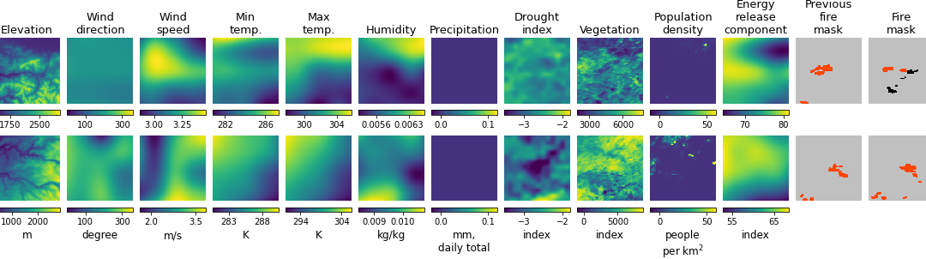
Figure 1. Two training examples, visualized with matplotlib.
Source: Next Day Wildfire Spread dataset
The two models required their respective inputs to be formatted differently, so the data preparation for each model is slightly different at this stage. While the general workflow and training process for both models are similar, and shown below in Figure 2, the architecture of each model is drastically different, as shown in Figures 3 and 4.
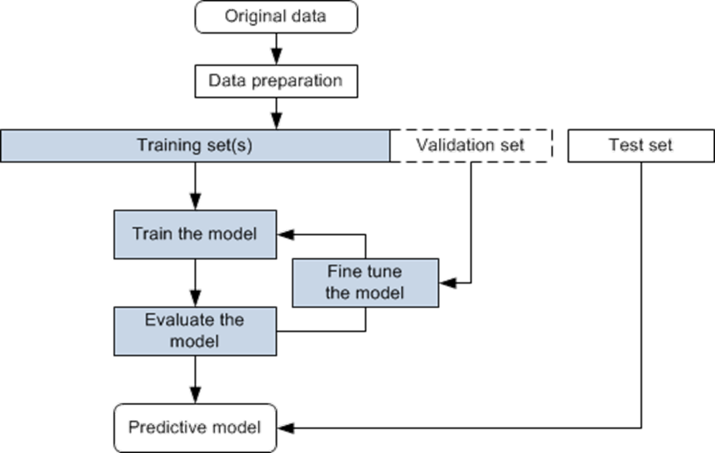
Figure 2. Illustration of the supervised machine learning workflow
Source:
The Convolutional Autoencoder model is constructed starting from a skip connection with two Convolutional layers paralleled with another parallel layer. The outputs from this skip connection are merged together. From here, four separate ResBlocks are created to encompass the encoder and decoder portions of the model. Each of these ResBlocks is created with upscaling or downscaling layers corresponding to whether or not they are encoding or decoding. The final layer of the model uses the sigmoid activation function.

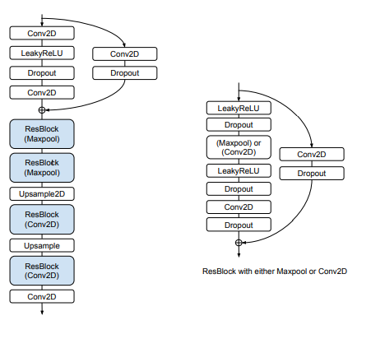
Figure 3. Illustration of the Convolutional Autoencoder model architecture
When used on the transformer model selected for this task, SegFormer, the dataset is both normalized and reshaped to forefront batch size, then input channels, then length and width. The implementation of the Convolutional Autoencoder model is identical to the one outlined in the original paper by the authors of the NDWS dataset, and the implementation of the SegFormer model is a black box. The model is called from the HuggingFace repository, with necessay configurations: namely, specification of the number of channels, and the input sizes of each sample.
For both models, the metric Mean IoU (Intersection over Union) will be utilized to achieve an accurate picture of the performance of each model. The hypothesis will either be confirmed or unrepresented by the difference in Mean IoU score between the Convolutional Autoencoder baseline model and the Transformer model, both used on the same problem.
Source: https://miro.medium.com/v2/resize:fit:1400/format:webp/1*QYWNa1YpxHLZW0ZRv9rOeg.png
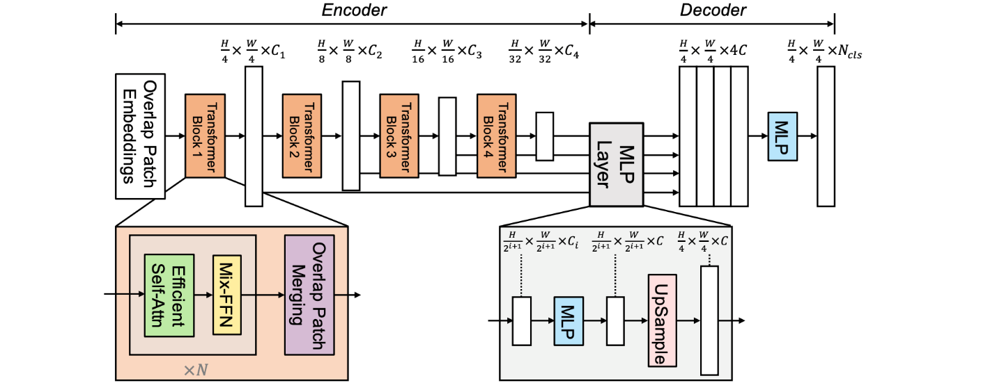
Figure 4. Illustration of the transformer model architecture
Source: SegFormer: Simple and Efficient Design for Semantic Segmentation with Transformers
Experimental results are collected through a WandB metric callback function for both the Convolutional Autoencoder and the Transformer. This collects measurement data such as loss and accuracy on each batch or epoch for each model through the training process. However, the final model performance comparison of prediction accuracy will take place at the evaluation stage.
- Figure 5. Configuration file of SSH connection to remote GPU
Source: Arthur Qin

Both autoencoder and transformer models are deep learning models, which requires huge computation on Graphic Processing Units (GPU) to train. Therefore, cloud computing is employed for training. Cloud training is accomplished by opening a secure connection to a cloud computer’s SSH, as shown above in Figure 5. Every instance of a cloud GPU results in a different IP address to be placed in the HostName category.
The process of setting up the pipeline can be automated and requires the following steps. First, using git clone, we clone a GitHub repository to the local files of the cloud GPU. Then, miniconda is downloaded and installed, and a new python environment is created. The dataset is downloaded from the web using wget, and all required dependencies like Tensorflow, Keras, and WandB are downloaded. Finally, a WandB API key is used to login, and the training process begins.

Results
Once the data are adequately prepared for the models, this section will present experimental results of our transformer models and the baseline autoencoder models for comparison.
Each run and iteration is logged independently using the WandB callback function to represent accuracy in the form of Mean IoU, or Intersection over Union. This metric was not initially the first choice – a metric called Area Under the Curve Precision Recall was the metric used in existing literature, but was incompatible with the transformer model used in this project.
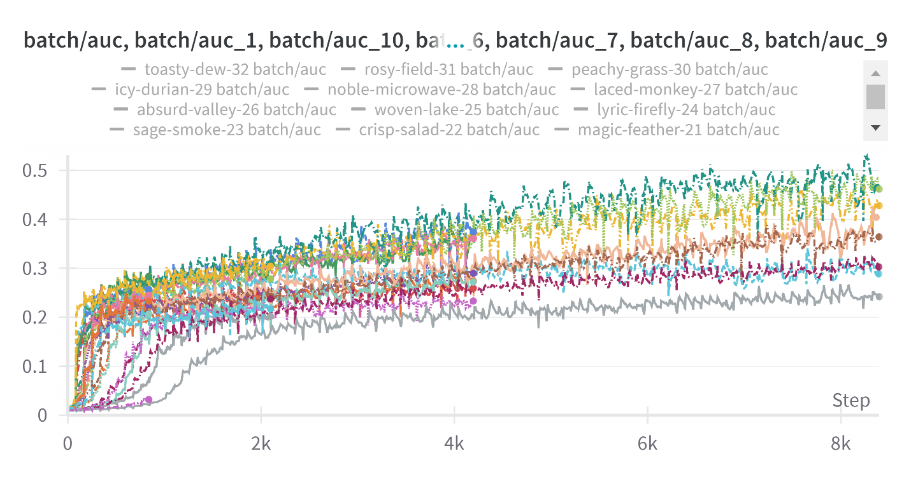
Figure 6. AUC PR performance of 30 transformer models overlayed.
Source: Arthur Qin
The chart above shows the training process of measuring AUC PR with the transformer model. This shows the improvements the model makes per batch of training. Each batch consists of 128 samples.
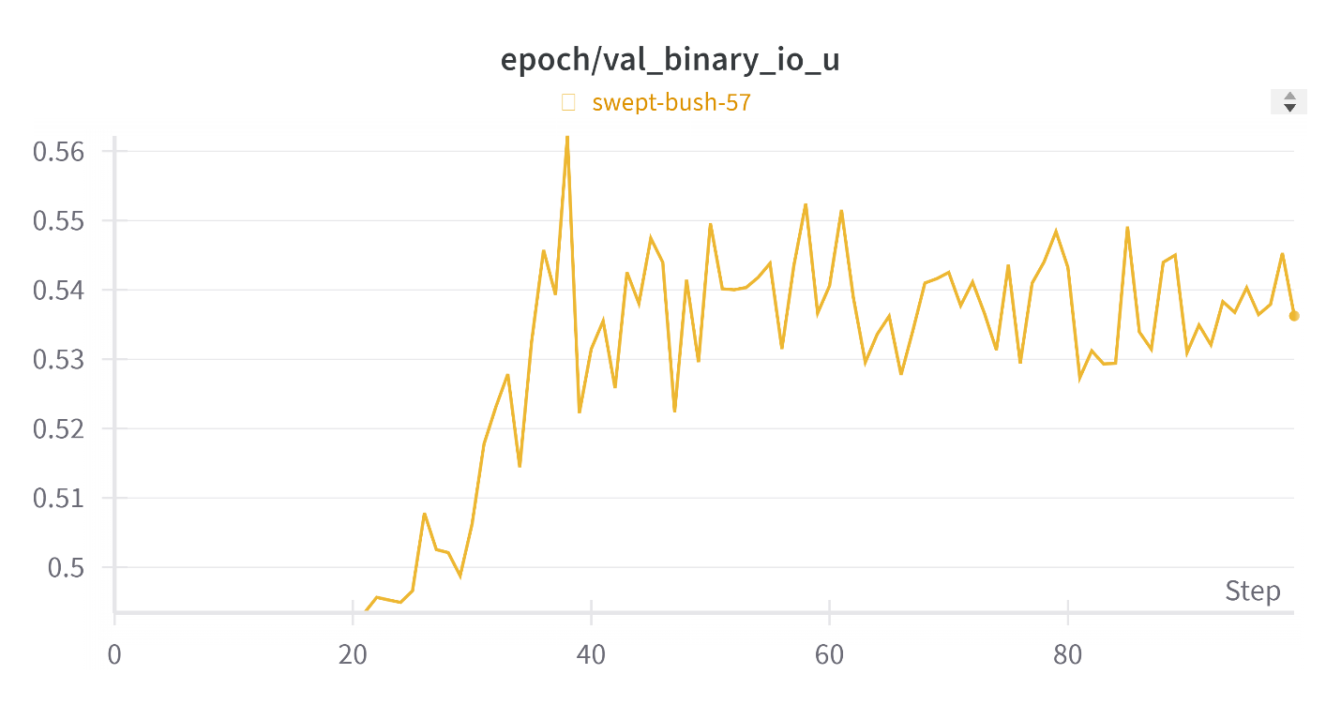
Figure 7. Mean IoU validation performance of optimal Convolutional Autoencoder
Source: Arthur Qin
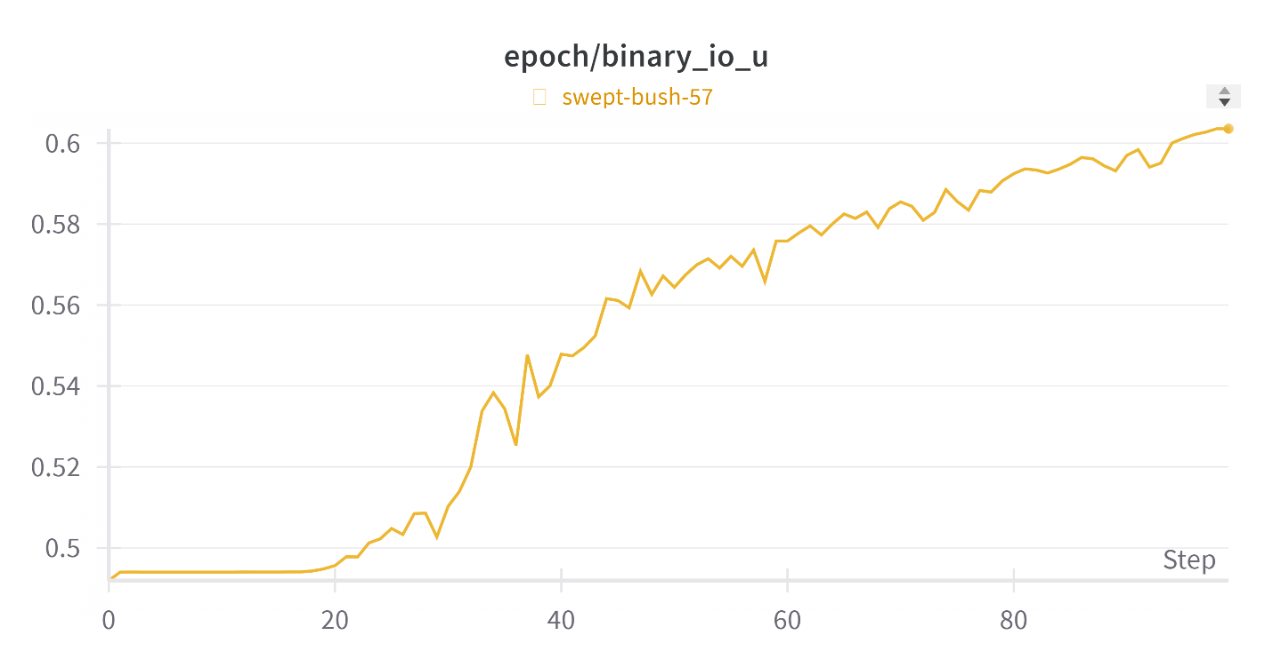
Figure 8. Mean IoU training performance of optimal Convolutional Autoencoder
Source: Arthur Qin
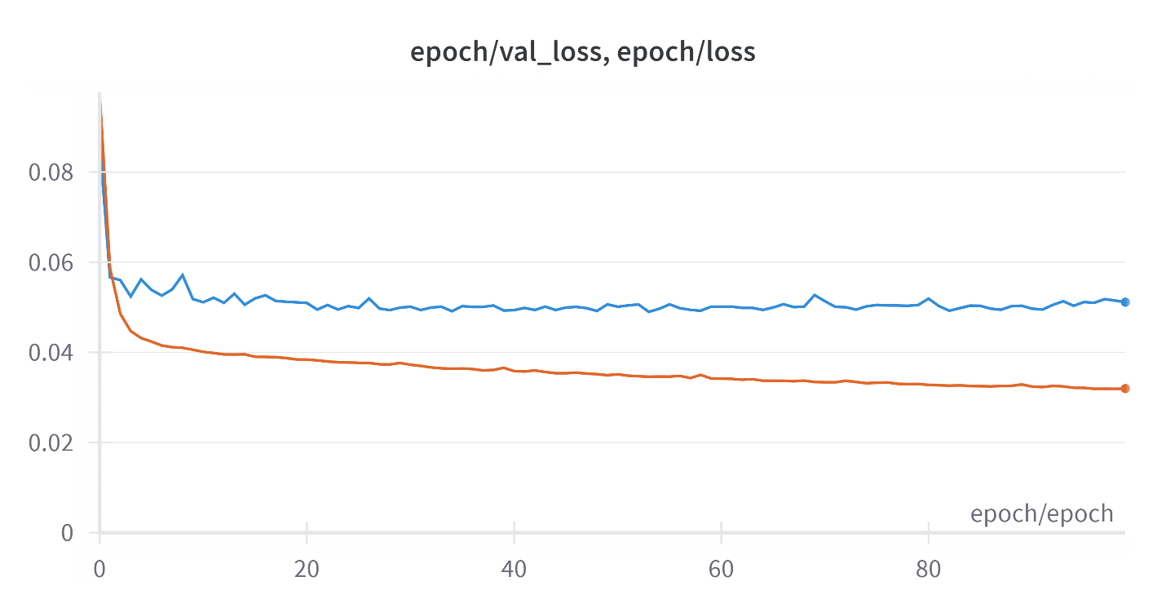
Figure 9.Training Loss performance of optimal Convolutional Autoencoder
Source: Arthur Qin
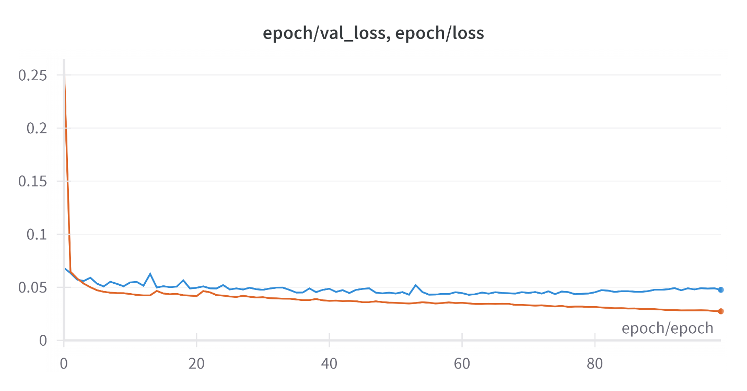
Figure 10. Training loss performance of SegFormer model.
Source: Arthur Qin
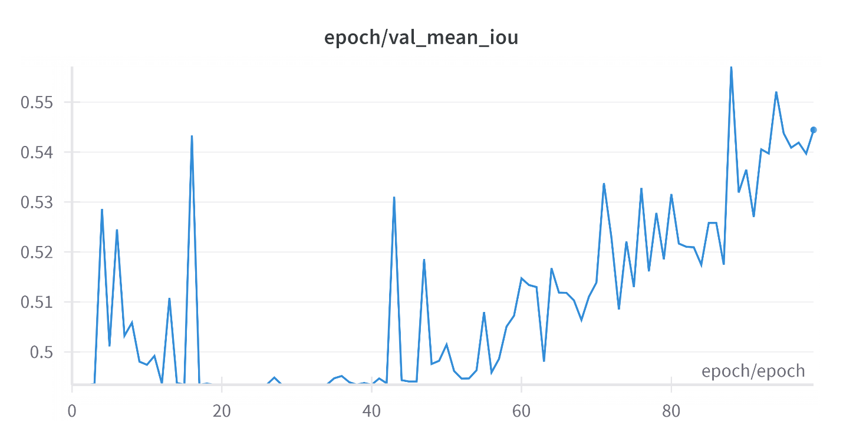
Figure 11. Mean IoU validation performance of best SegFormer iteration.
Source: Arthur Qin

Discussion
The evaluation result shows that the transformer model, SegFormer, achieves a prediction accuracy higher than that of the Convolutional Autoencoder. The usage of transformer type models for the task of wildfire propagation prediction has not been pursued extensively in current academia. This result demonstrates that even a model meant for more complex image segmentation tasks can achieve success comparable to the most optimized convolutional model. A deep learning model was trained to learn how a wide variety of environmental data can play a role in the growth of a wildfire from historical data, instead of existing predetermined analytical or numerical models. This endeavor is different from most of the existing applications of Artificial Intelligence and deep learning in wildfire prediction work, which focus on early fire detection and prevention. After a wildfire inevitably starts, accurate prediction of fire propagation is crucial for firefighters to decide resource allocation and best actions to minimize the damage to the environment and human society. The formulation of our output data can reduce the required training for firefighters by providing a visual prediction of fire growth as a future fire map. This new data-driven approach is flexible and can be easily customized to different geographical area using transfer learning methods if needed.
One limitation of the model comes from the data used. During training of both the Convolutional Autoencoder and the SegFormer model, the data showed light indicators of overfitting, in which the model over adapts to the dataset, often due to low volume of data. A major step forward for future research would be development or robust data augmentation of wildfire data, which could substantially boost the validity and effectiveness of training machine learning models.
Research could be improved if a custom transformer model was to be built explicitly for the binary image segmentation task require by this unique wildfire propagation prediction problem. A recurring problem was the gap between sophistication required for the task at hand and the model used for the task, in which data input sizes were arbitrarily changed or the features of the model were too complex for the model’s prediction. This could be alleviated by lowering learning rate or reducing training iterations, or performing data augmentation. However, ideally, a custom transformer model would be built specifically for this problem. This would also require iteration to find the optimal hyperparameters for such a model.

References
Deng, Qimin. “U-Net: A Deep-Learning Method for Improving Summer Precipitation Forecasts in China.” Atmospheric and Oceanic Science Letters, Elsevier, 18 Dec. 2022, www.sciencedirect.com/science/article/pii/S1674283422002100.
Green, D.G. Shapes of simulated fires in discrete fuels. Ecol. Mod. 20:21-32, 1983.
Huot, F., Hu, L. R., Goyal, N., Sankar, T., Ihme, M., & Chen, Y.-F. (2022, March 2). Next Day Wildfire Spread: A Machine Learning Data Set to Predict Wildfire Spreading from Remote-Sensing Data. arXiv.org e-Print archive. https://arxiv.org/pdf/2112.02447
French, I.A. Visualisation techniques for the computer simulation of bushfires in two dimensions. M.S. thesis, University of New South Wales, Australian Defense Force Academy, 1992.
Xu, J. and Lathrop, R.G., “Geographic information system based wildfire spread simulation”. Proc. 12th Conf. Fire and Forest Meteorology, pp. 477-484. 1994.
Finney, M.A.,“Modeling the spread and behavior of prescribed natural fires”. Proc. 12th Conf. Fire and Forest Meteorology, pp. 138-143. 1994.
Finney, M.A., FARSITE, Fire Area Simulator--model development and evaluation. No. 4. US Department of Agriculture, Forest Service, Rocky Mountain Research Station, 1998.
Rothermel, R.C., How to predict the spread and intensity of forest and range fires. Vol. 143. US Department of Agriculture, Forest Service, Intermountain Forest and Range Experiment Station, 1983.
Rubi, J., “Application of Machine Learning Models in the Behavioral Study of Forest Fires in the Brazilian Federal District Region.” Engineering Applications of Artificial Intelligence, Pergamon, 5 Dec. 2022, www.sciencedirect.com/science/article/abs/pii/S095219762200639X.
Feunekes, U., Error analysis in fire simulation models. M.S. thesis, University of New Brunswick, Fredericton, 1991.
Zohouri Haghian, P. “Deep representation learning and prediction for forest wildfires,” Master’s thesis, University of Waterloo, 2019.
Radke, D.; Hessler, A.; Ellsworth, D. “FireCast: Leveraging deep learning to predict wildfire spread.” in IJCAI, 2019, pp. 4575–4581.
Gozalo-Brizuela, R.; Garrido-Merchan. E. C. "ChatGPT is not all you need. A State of the Art Review of large Generative AI models." arXiv preprint arXiv:2301.04655 , 2023. Available online https://doi.org/10.48550/arXiv.2301.04655
Vaswani, A.; Shazeer, N.; Parmar, N.; Uszkoreit, J.; Jones, L.; Gomez, A.; Kaiser, L.; Polosukhin. L. "Attention is all you need." Advances in neural information processing systems. Vol. 30, 2017.
Xie, E., Wang, W., Yu, Z., Anandkumar, A., Alvarez, J. M., & Luo, P. (2021), “SegFormer: Simple and Efficient Design for Semantic Segmentation with Transformers”, NEURIPS
https://huggingface.co/docs/evaluate/package_reference/main_classes#evaluate.EvaluationModule
https://www.tensorflow.org/api_docs/python/tf/keras/metrics/MeanIoU
https://www.tensorflow.org/api_docs/python/tf/keras/metrics/BinaryIoU
https://www.tensorflow.org/api_docs/python/tf/keras/metrics/AUC
https://github.com/huggingface/evaluate/tree/main/metrics/mean_iou
https://huggingface.co/docs/transformers/model_doc/segformer

Appendix
Figure 1. Illustration of the supervised machine learning workflow
Figure 2, An example training image
Source: Next Day Wildfire Spread dataset
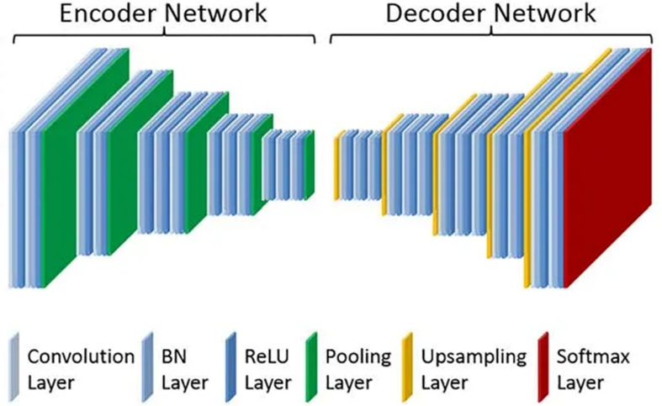
Figure 3. Illustration of an Convolutional Autoencoder model
Figure 4. Chart depicting AUC PR performance of 30 transformer model iterations overlayed.
Source: Arthur Qin
Figure 5. Chart depicting Mean IoU validation performance of best Convolutional Autoencoder iteration.
Source: Arthur Qin
Figure 6. Chart depicting Mean IoU training performance of best Convolutional Autoencoder iteration.
Source: Arthur Qin
Figure 7. Chart depicting loss training performance of best Convolutional Autoencoder iteration.
Source: Arthur Qin
Figure 8. Chart depicting loss training performance of best SegFormer iteration.
Source: Arthur Qin
Figure 9. Chart depicting Mean IoU validation performance of best SegFormer iteration.
Source: Arthur Qin

